**Defining data as constants**

Throughout this course, we will use tensorflow version 2.1 and will exclusively import the submodules needed to complete each exercise. This will usually be done for you, but you will do it in this exercise by importing constant from tensorflow.

After you have imported constant, you will use it to transform a numpyarray, credit_numpy, into a tensorflow constant, credit_constant. This array contains feature columns from a dataset on credit card holders and is previewed in the image below. We will return to this dataset in later chapters.

Note that tensorflow version 2.0 allows you to use data as either a numpy array or a tensorflow constant object. Using a constantwill ensure that any operations performed with that object are done in tensorflow.

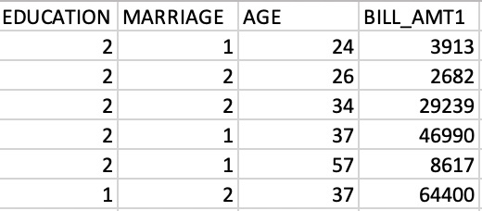

**Instructions**

**100 XP**

**Instructions**

**100 XP**

* Import the constant submodule from the tensorflow module.
* Convert the credit_numpy array into a constant object in tensorflow. Do not set the data type.

# Import constant from TensorFlow

from tensorflow import constant

# Convert the credit_numpy array into a tensorflow constant

credit_constant = constant(credit_numpy)

# Print constant datatype

print('The datatype is:', credit_constant.dtype)

# Print constant shape

print('The shape is:', credit_constant.shape)

Excellent! You now understand how constants are used in tensorflow. In the following exercise, you'll practice defining variables.